# Workstation DX Setup

Jian Jiao

**DR: Disaster recovery**

# Background

To prepare for certain disaster recovery situations, we need some documentation and information on our local workstation in case we are unable to reach the original location for some reason. This process involves a PowerShell script that is scheduled to run daily using Task Scheduler to perform replication.

# Setup

1. Copy the DX directory and update scripts from the network drive to your local workstation.

Run the command in Command Prompt. It will copy all the files to C:\DR

Xcopy “Z:\MRKT\Digital Experience\Processes\setup-dr-local-workstation\DR” C:\DR\ /E /H

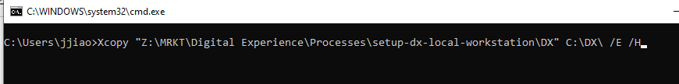

After running the command, it will create a DR (Disaster Recovery) folder in your local C drive and three scripts in it.

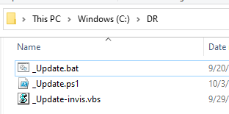

1. Open Task Scheduler

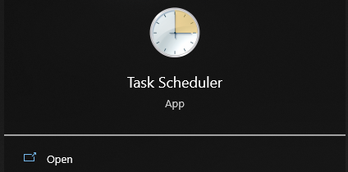

1. Create a new task

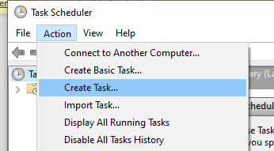

1. Set task name: DR Update

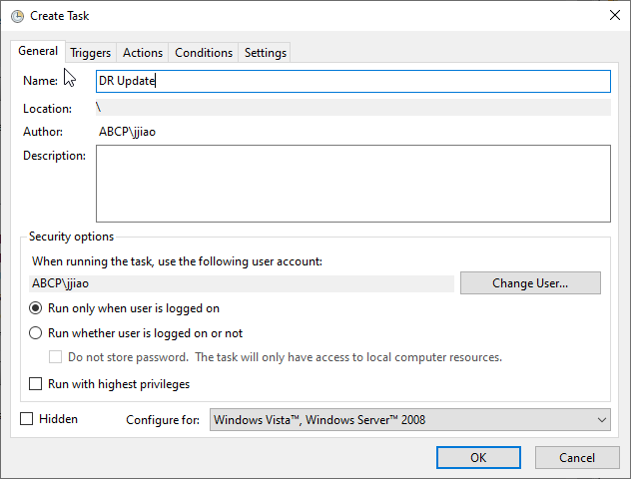

1. In Triggers tab, create a new trigger

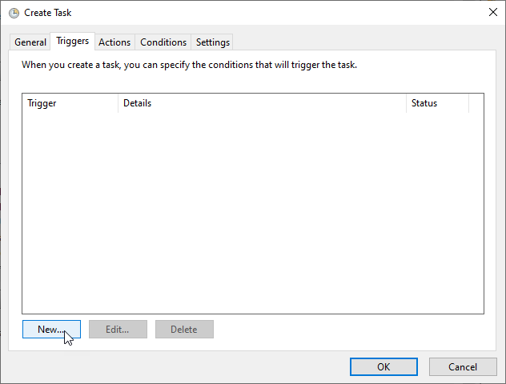

1. Settings -> Daily

Start -> 9:20:00 (or 09:20:00 AM for 12h clock)

Tips: Please set this timer according to your own working hours. (Make sure your computer is connected to the company's VPN)

Click OK.

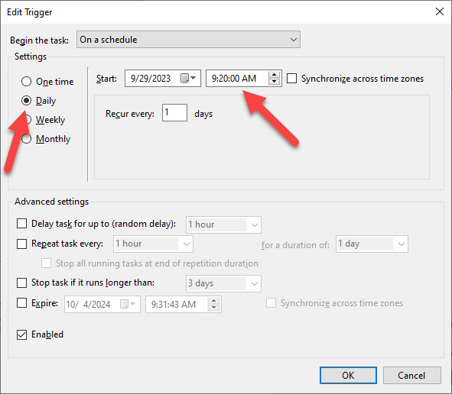

1. In Actions tab, create a new action

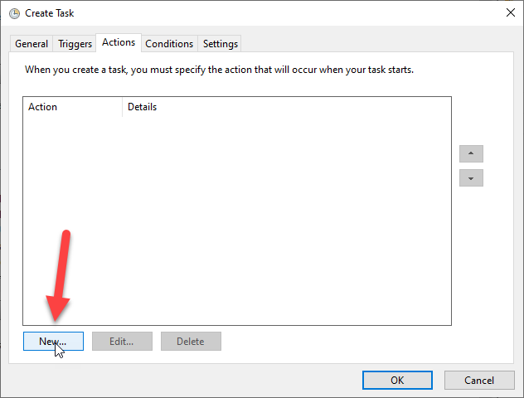

1. Program/Script: -> C:\Windows\System32\wscript.exe

Add arguments: -> C:\DR\_Update-invis.vbs

Start in: -> C:\DR

OK

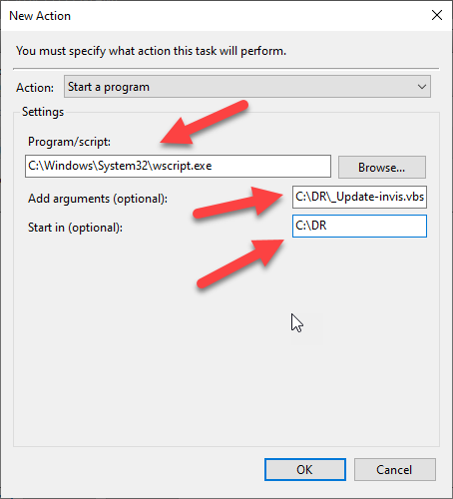

1. Hit Ok, close the Properties window.

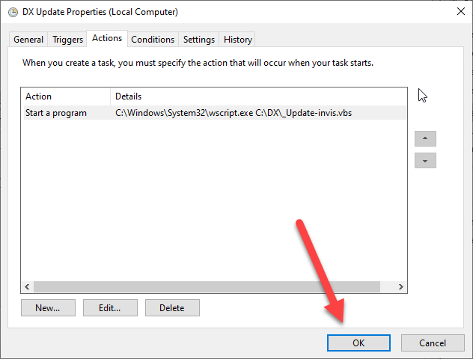

# Validation

1. Open Task Scheduler.
2. a). Select the Task Scheduler Library

b). Select the DR Update task

c). Hit Run

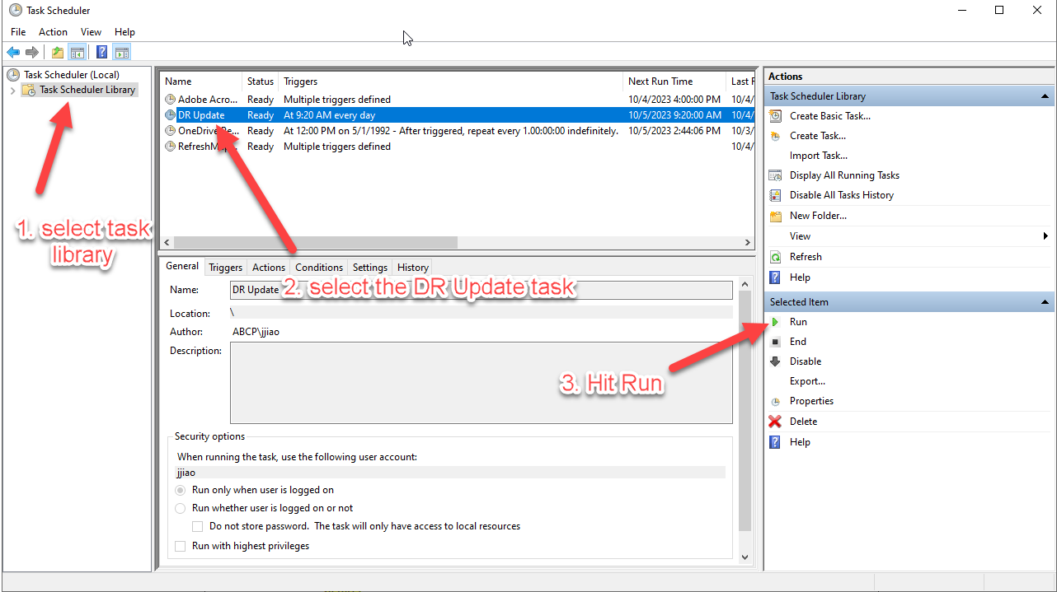

1. Check the contents of C:\DR. You should see new folders and files appear over the next few minutes.

**Before**:

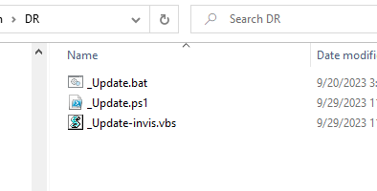

**After:**

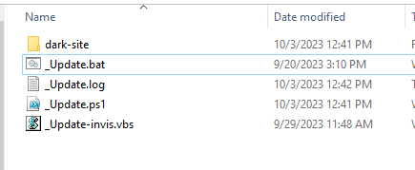

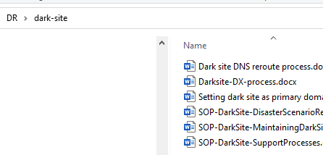

1. Next day, you should find the latest update date in the update log file

